**CLOUD COMPUTING**

**CLOUD COMPUTING**

Cloud computing is a model of delivering computing resources, including servers, storage, databases, networking, software, analytics, and intelligence, over the internet. This model provides on-demand access to a shared pool of configurable computing resources that can be rapidly provisioned and released with minimal management effort or service provider interaction. Cloud computing offers numerous advantages over traditional on-premises IT infrastructure, including cost savings, flexibility, scalability, and reliability.

**Infrastructure as a service (IaaS):**

This type of cloud computing provides virtualized computing resources, such as servers, storage, and networking, over the internet. IaaS allows users to scale up or down their computing resources based on their needs and pay only for what they use. Popular IaaS providers include Amazon Web Services (AWS), Microsoft Azure, and Google Cloud Platform (GCP).

**Platform as a service (PaaS):**

This type of cloud computing provides a platform for developing, deploying, and managing applications without having to worry about the underlying infrastructure. PaaS providers typically offer a set of tools and services that allow developers to focus on writing code rather than managing servers and databases. Popular PaaS providers include Heroku, Google App Engine, and Microsoft Azure.

**Software as a service (SaaS):**

This type of cloud computing provides applications that are accessed over the internet, rather than installed on a local computer or server. SaaS providers typically offer a subscription-based pricing model and handle all aspects of the application, including maintenance, security, and upgrades. Popular SaaS applications include Salesforce, Dropbox, and Google Works

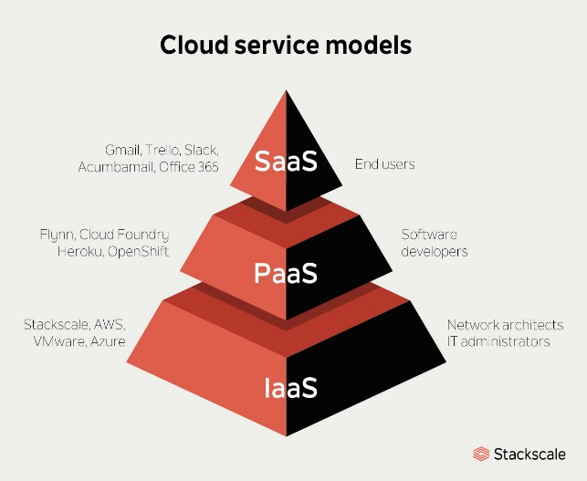

**AWS (Amazon Web Services):**

The Amazon Web Services (AWS) platform provides more than 200 fully featured services from data centers located all over the world, and is the world’s most comprehensive cloud platform.

Amazon Web Service is an online platform that provides scalable and cost-effective cloud computing solutions.

AWS is a broadly adopted cloud platform that offers several on-demand operations like computer power, database storage, content delivery, etc., to help corporates scale and grow.

**Components of AWS**

**Amazon S3 (Simple Storage Service)**

Object storage service for storing and retrieving any amount of data. It is highly scalable, durable, and commonly used for static website hosting, backup, and data archiving.

**Amazon EC2 (Elastic compute cloud)**

Virtual servers in the cloud, allowing users to run applications. Users can choose different instance types based on their computing needs.

**Amazon Lambda**

Serverless compute service that lets you run code without provisioning or managing servers. It automatically scales based on the incoming request volume.

**Amazon DynamoDB**

Managed NoSQL database service that provides fast and predictable performance with seamless scalability. It is suitable for applications requiring low-latency access to small amounts of data.

**Elastic compute cloud (EC2):**

Amazon Elastic Compute Cloud (Amazon EC2) provides on-demand, scalable computing capacity in the Amazon Web Services (AWS) Cloud. Using Amazon EC2 reduces hardware costs so you can develop and deploy applications faster. You can use Amazon EC2 to launch as many or as few virtual servers as you need, configure security and networking, and manage storage. You can add capacity (scale up) to handle compute-heavy tasks, such as monthly or yearly processes, or spikes in website traffic. When usage decreases, you can reduce capacity (scale down) again.

**Features of Amazon EC2**

**Instances**

Virtual servers.

**Amazon Machine Images (AMIs)**

Preconfigured templates for your instances that package the components you need for your server (including the operating system and additional software).

**Instance types**

Various configurations of CPU, memory, storage, networking capacity, and graphics hardware for your instances.

**Key pairs**

Secure login information for your instances. AWS stores the public key and you store the private key in a secure place.

**Instance store volumes**

Storage volumes for temporary data that is deleted when you stop, hibernate, or terminate your instance.

**Amazon EBS volumes**

Persistent storage volumes for your data using Amazon Elastic Block Store (Amazon EBS).

**Regions, Availability Zones, Local Zones, AWS Outposts, and Wavelength Zones**

Multiple physical locations for your resources, such as instances and Amazon EBS volumes.

**Security groups**

A virtual firewall that allows you to specify the protocols, ports, and source IP ranges that can reach your instances, and the destination IP ranges to which your instances can connect.

**Elastic IP addresses**

Static IPv4 addresses for dynamic cloud computing.

**Tags**

Metadata that you can create and assign to your Amazon EC2 resources.

**Virtual private clouds (VPCs)**

Virtual networks you can create that are logically isolated from the rest of the AWS